Reference:
Quarks and Leptons : An introductory course in modern particle physics, Halzen and Martin.

Chapters:

- Chapter 8: The structure of Hadrons
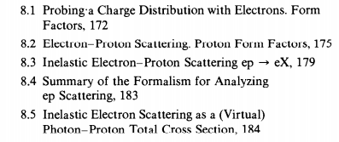

- Chapter12: Weak interactions
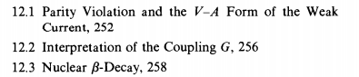
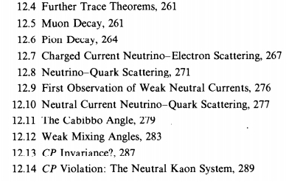

- Chapter13: Electroweak interactions
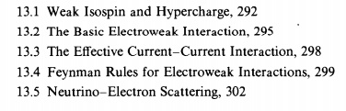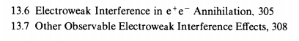

- Chapter 15: The Weinberg- Salam Model and Beyond
