Random Processes
Instructor:
- Mehri Mehrjoo
  - Graduated from the University of Waterloo, Canada
  - Interested in computer and communication networks research
- Email me anything at
  - mehrimehrjoo@gmail.com
  - mehrjoo@ece.usb.ac.ir
Textbook:

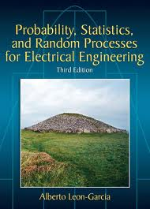
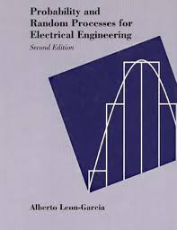
- Alberto Leon-Garcia, Probability, Statistics, and Random Processes For Electrical Engineering, 3rd. Ed. Prentice Hall, 2008.

Grading Scheme:
- Quiz: 60%
- Final: 40%

Course Material:
- Probability: Random experiments, axioms of probability, conditional probability and statistical independence.
- Random Variables: CDF and PDF, functions of random variables, expected value of random variables, Chebyshev inequality, characteristic function, probability generating function, entropy.
- Multiple random variables: joint PDF, conditional probability and conditional expectation, correlation and covariance, jointly Gaussian random variables, Mean Square Estimation.
- Sum of random variables, Law of Large Numbers, Central Limit Theorem, Confidence Intervals.
- Random Processes: Mean, Autocorrelation and Autocovariance, Ergodicity, Stationarity.
- Filtering of Random Signals: Power Spectral Density, Response of Linear Systems to Random Signals.
- Markov Chains and the Elements of Queuing Theory.

