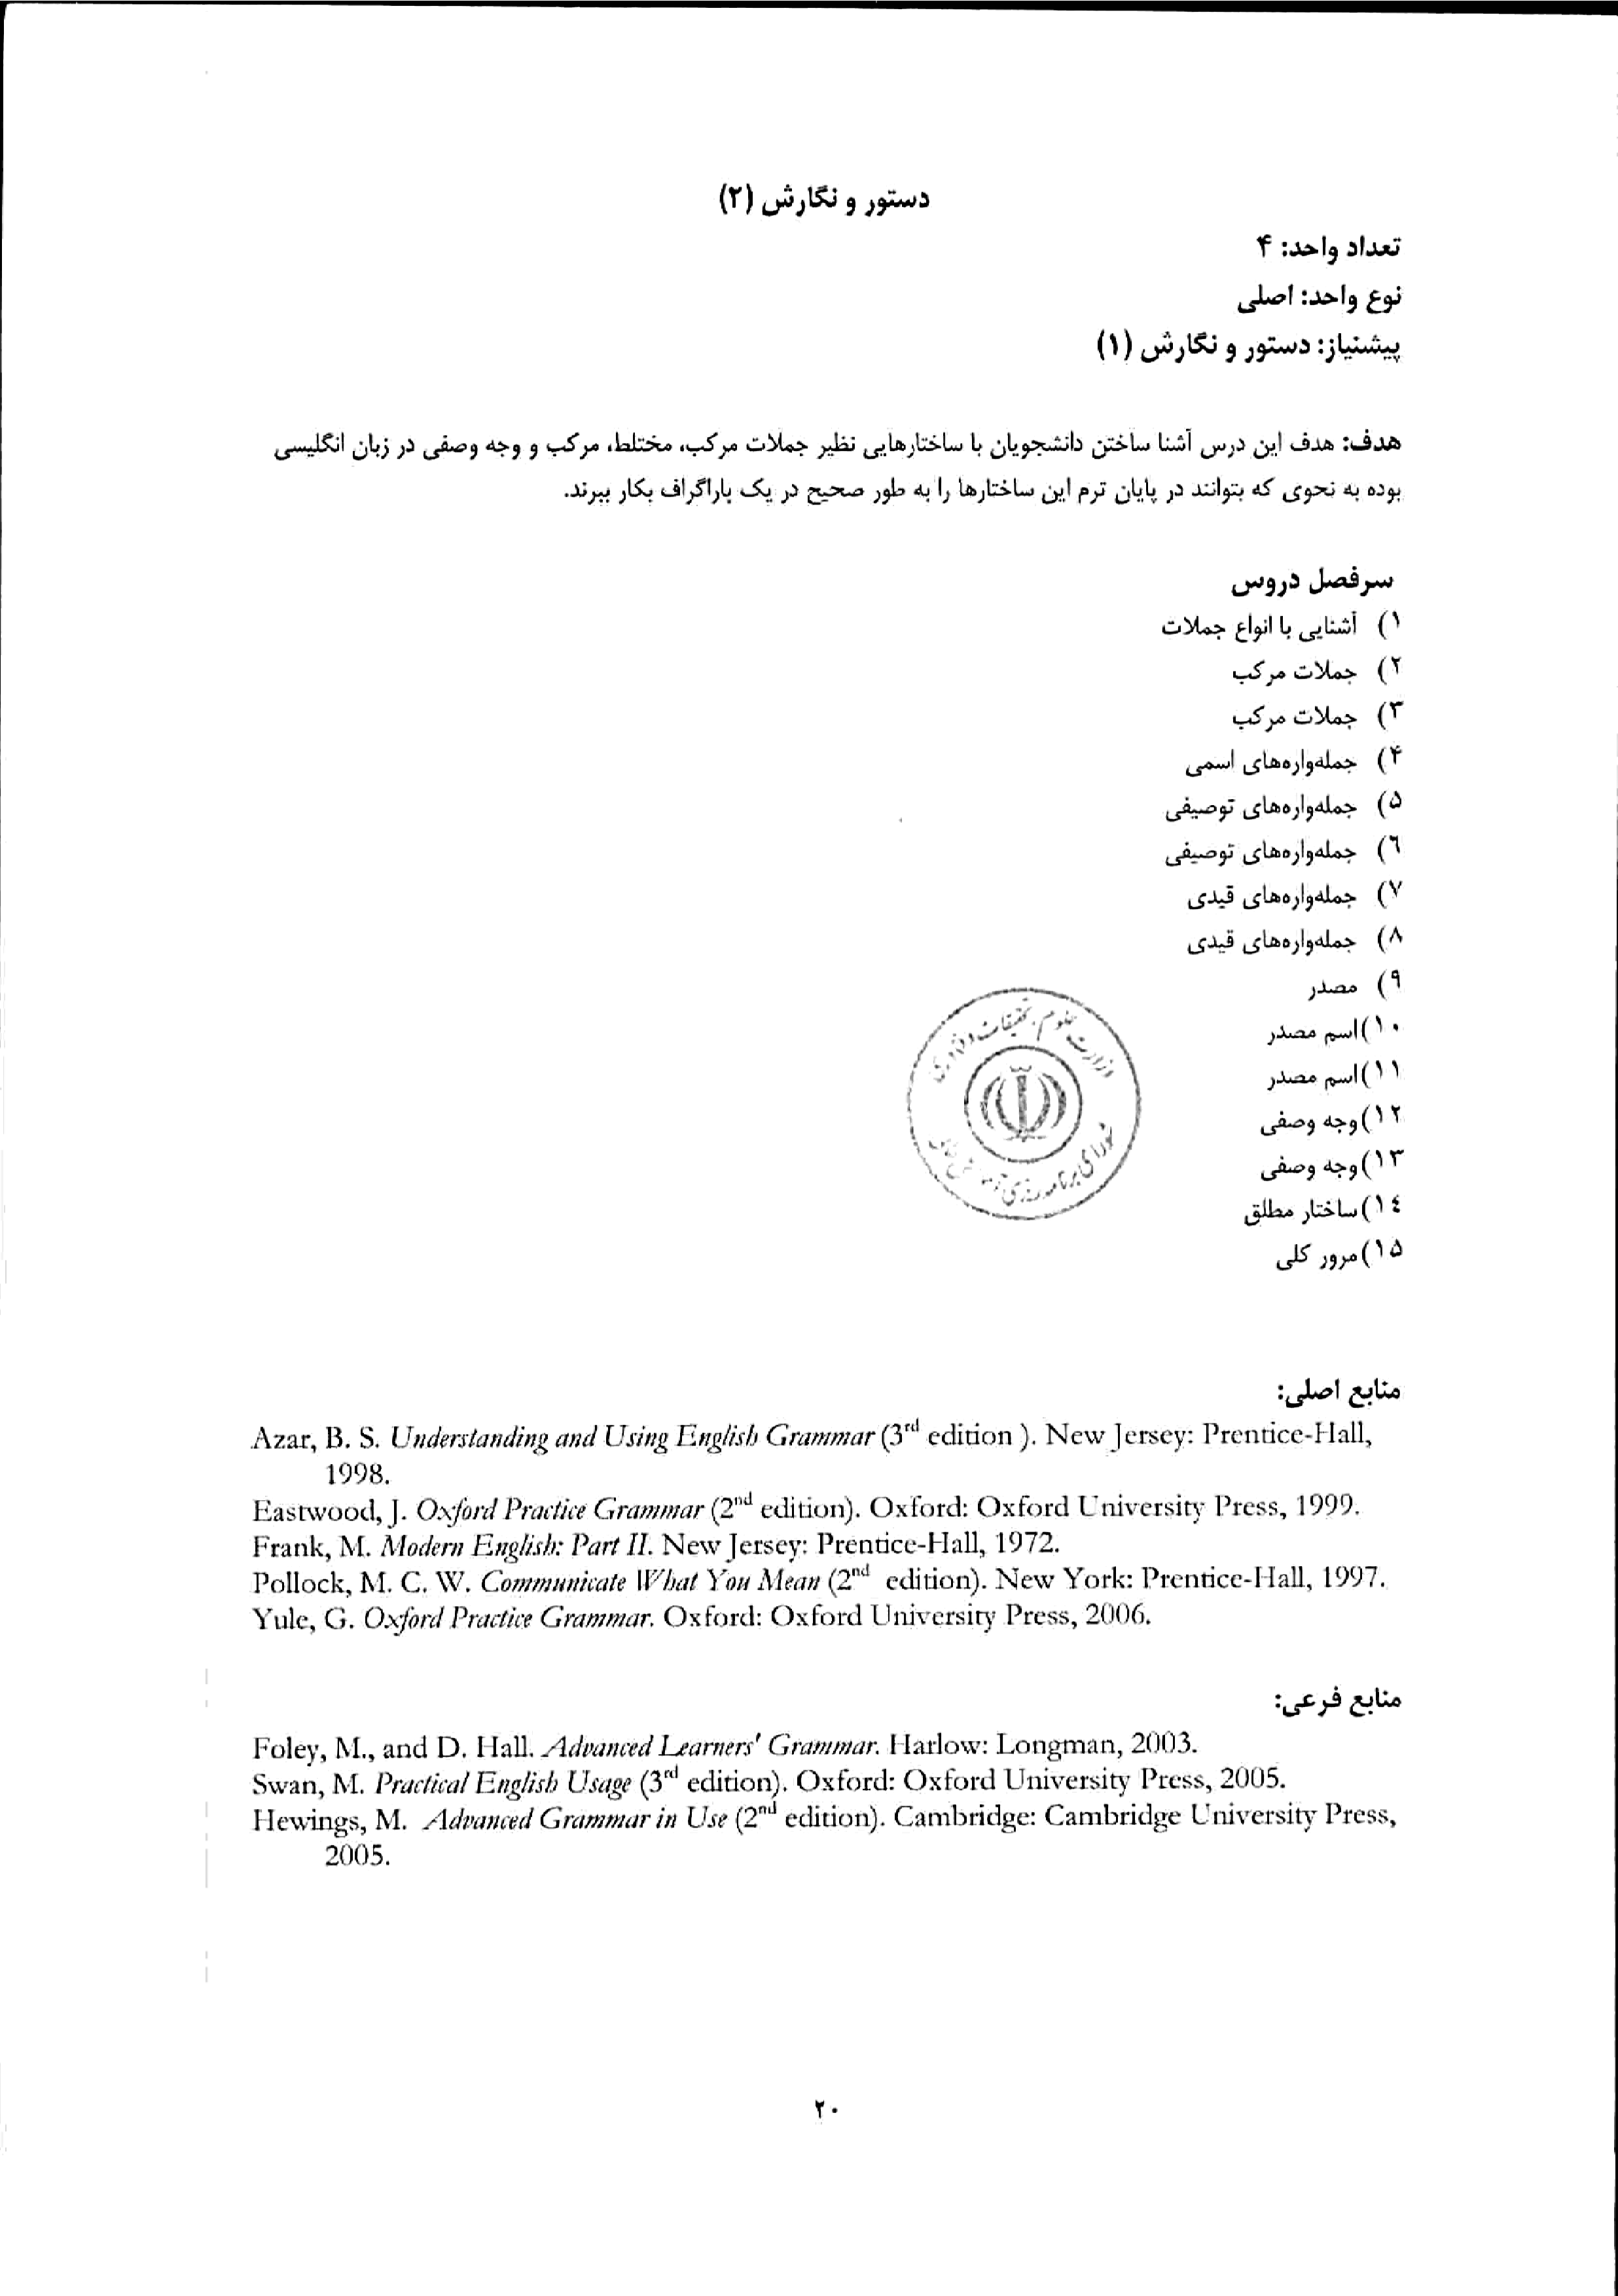

Source book:
Communicate What You Mean: A Concise Advanced Grammar

Week 1. Forming the passive
- simple present - simple past - present continuous - past continuous
- future with will - future with be going to

Week 2. Forming the passive:
- present perfect - past perfect - future perfect
- present infinitive - modals

Week 3. Indirect objects and direct objects as passive subjects
Advisability vs. necessity
To use the meanings of advisability vs. necessity with modal auxiliaries

Week 4. Past regrets and criticism: Should, Ought to
Logical conclusion vs. expectation
To use the meanings of logical conclusion vs. expectation with modal auxiliaries

Week 5. Could
To use the meanings of suggestions with modal auxiliaries
Possibilities: May, Might, Could
To use the meanings of possibilities with modal auxiliaries

Week 6. Negative possibilities and impossibilities
To use the meanings of negative possibilities and impossibilities with modal auxiliaries
Degrees of certainty
To use the meanings of degrees of certainty with modal auxiliaries

Week 7. Future real
making and using future real conditional sentences
Present/future unreal
making and using present/future unreal conditional sentences

week 8. Past unreal
making and using past unreal conditional sentences
Replacing if
replacing if in conditional sentences

week 9. Mixed conditional sentences
making and using mixed conditional sentences

week 10. Simple infinitives and infinitive phrases - Infinitive/infinitive phrase functioning as subject and subject complement
making and using simple infinitives and infinitive phrases, and infinitive/infinitive phrase functioning as subject and subject complement

week 11. Infinitive/infinitive phrase functioning as direct object
making and using infinitive/infinitive phrase functioning as direct object
Infinitive/infinitive phrase functioning as adjective and adjective complement
making and using infinitive/infinitive phrase functioning as adjective and adjective complement

week 12. Infinitive/infinitive phrase functioning as adverb
making and using infinitive/infinitive phrase functioning as adverb
Reduction with infinitive phrases - Infinitive/infinitive phrase with Enough and Too
reducing infinitive phrases and making infinitive/infinitive phrase with enough and Too

week 13. making and using gerunds
Gerunds/gerund phrase functioning as subject and subject complement
making and using gerunds/gerund phrase functioning as subject and subject complement

week 14. Gerunds/gerund phrase functioning as direct object
making gerunds/gerund phrase functioning as direct object

week 15. Gerund as direct object vs. infinitive as direct object
making and using gerund as direct object vs. infinitive as direct object
Gerunds/gerund phrase functioning as object of a preposition
making and using gerunds/gerund phrase functioning as object of a preposition

